City Council of Alexandria, Virginia
Public Hearing Meeting
Saturday, March 17, 2012

Open Mike
Concerns about the Failure To Plan Bicycle Facilities on Beauregard Street
by
Nancy R. Jennings

My name is Nancy Jennings and I live at 2115 Marlboro Drive. I have reluctantly participated in the process to develop the Beauregard Corridor Small Area Plan since 2009 and have spoken in the past to you on behalf of Seminary Hill Association, Inc. As you well know, Seminary Hill residents are opposed to the I-395 HOV ramp to Seminary Road because it will bring more cut through traffic to the City, we are opposed to the needless expense for the ellipse at Seminary and Beauregard, and we opposed the High Capacity Transit Way on Corridor C because it did not solve the traffic problems which are on Seminary Road not Beauregard. I have spoken on behalf of Seminary Hill Association in favor of the City acquiring more land at Beauregard and Seminary Road for public benefit as parks and potentially a new school.
My comments today are my own based on my participation in the Beauregard Corridor plan process and as a member of the High Capacity Transit Corridor Working Group. Because of the fast track you have put the Beauregard Corridor Small Area Plan I have no time to see my Board’s views on what I am about to say. At the High Capacity Transit Working Group meeting last Thursday, I suggested—based on the groups decisions about Corridors A and B—that we revisit Corridor C. Street cars no longer are being considered as an option for the City so transit in separate lanes on Corridor C is likely no longer needed. Also a detailed bike facilities route is needed in Corridor C as was done in Corridor B.
All we have now about bicycle facilities in this corridor is:
Wording from DRAFT Beauregard Corridor Small Area Plan: Pedestrian and Bicycle Network—Streets within the Plan area will include pedestrian facilities with varying sidewalk or path widths in context of the surrounding uses. Bicycle facilities will be built along Beauregard Street, Seminary Road, and Sanger Avenue (Figure 52). There will be improved pedestrian and bicycle access to commercial, recreational and transit within the Plan area, and connectivity to adjacent neighborhoods and schools.
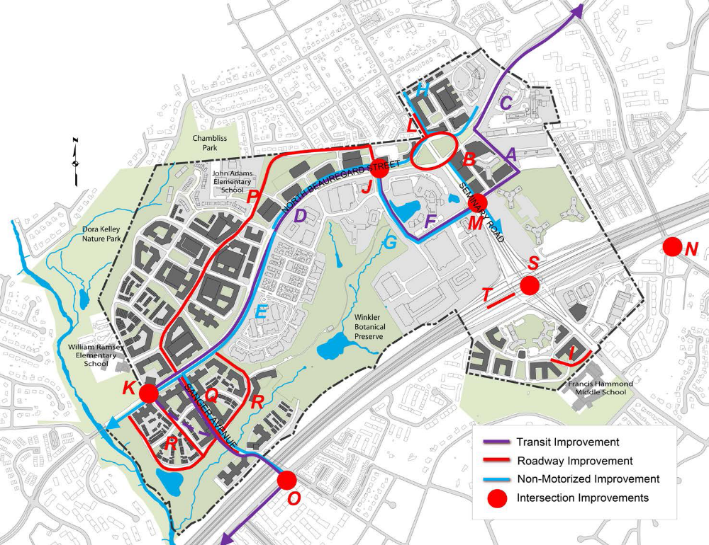
A Beauregard bicycle facility is critical to connecting Alexandria’s trails to those in the greater Washington DC area. It should connect to the Holmes Run bike path probably by a bridge and should run along the whole north side of Beauregard, past NOVA, and connect to the bike route in Arlington at Walter Reed Drive and King Street (where the City has another road improvement project). In the haste to pass the Beauregard Corridor plan, please make staff provide proper bicycle facilities along one side of this corridor that connects to something. Just including it as a concept among a complete street design is not enough and the marine clay in this corridor will prevent complete streets from ever being built.
Thank you for your consideration.

