
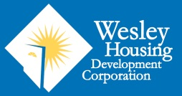

You are Invited:
FPC’s Affordable Housing Neighborhood Introduction Meeting
Tuesday, May 23, 2017 at 7:00-8:00pm at
Fairlington Presbyterian Church, 3846 King St, Alexandria, VA

FPC Proposed Affordable Housing: Information for our Neighbors

Fairlington Presbyterian Congregational Approval of Land Sale
In 2016, the Session of Fairlington Presbyterian Church (the elected lay leadership of the church) began considering proposals for the redevelopment of a portion of the Church site. Wesley Housing Development Corporation, a 40-year old non-profit provider of affordable housing solutions in Northern Virginia, provided a proposal to purchase a portion of the current church parking lot and to develop a high-quality, affordable rental housing building consisting of 75-81 units on the site. The Session determined that the proposal was worthy of consideration as the addition of high-quality, committed affordable housing in the Fairlington area would be a worthy extension of the Church’s mission and a long-lasting benefit to Alexandrians with low- and moderate-incomes.

On May 7, 2017, the members of Fairlington Presbyterian Church (FPC) took a congregational vote to move forward with the sale of a portion of the property and negotiate the terms of a purchase contract with Wesley Housing. The design of any new building was not voted upon, but the authority to make decisions about the design was entrusted to the Session.

Process Going Forward and Opportunities for Involvement
Having voted to sell the land, FPC now invites our neighbors to attend a meeting on May 23 at 7pm at Fairlington Presbyterian Church, 3846 King St, Alexandria, VA 22302. This will provide an introduction to the decision made by the congregation, the proposed design developed by the FPC Design Working Group and the process with the City that will be followed. Neighbors of the church and community members are welcome to attend.

This will be the first official and formal outreach made by FPC to our neighbors. Our work as a congregation over the past few months was to discern whether or not this proposal was something God called us to pursue. We spent the past many months having internal conversations about whether affordable housing is a mission our congregation is being called to support, and how parking and open space would optimally be reconfigured on our site with the addition of the residential building.

Making Design Recommendations
Prior to the formal congregational vote, FPC formed a Design Working Group (DWG) to ensure that all FPC priorities could be met prior to allowing the Purchase and Sale Agreement to be executed. As such, the DWG considered options for how the property could be configured to accommodate the proposed residential building and meet the needs of the Church and Potomac Crescent Waldorf School. Long-time and more recent FPC congregants volunteered to serve on the Design Working Group, along with the Chairman of the Potomac Crescent Waldorf School (PCWS).

As part of the development of the residential building, WHDC will provide new parking facilities for the Church as well as a new combined outdoor worship and play space, among other site amenities. The number of church spaces will by determined by the congregation and will meet the City requirement. The residential building will provide sufficient underground parking for its residents. The number of parking spaces, preservation of open space and site circulation were the three highest priorities of the DWG and will remain such during the design process.

The rendering on the second page is the current proposed site design that was submitted to the City of Alexandria for the Concept 1 review process. The Congregation provided feedback to this proposed design already as has the City of Alexandria. That feedback from both the Congregation and the City will be incorporated into the design submitted during the Concept 2.

As is true of most design projects such as this one, the site plan design will almost certainly continue to be modified in response to congregational feedback and the public approval process.
Alexandria City Development Review Process
The City of Alexandria has a formal process for projects, such as this one, that require a Development Special Use Permit with Site Plan (DSUP). An approved DSUP must occur before building permits can be released.

In addition to the Wesley Housing’s proposed community outreach, as be seen in this chart below, this five-step formal Site Plan approval process includes required communication with the neighbors of a proposed development project. This typically occurs during the Concept 2 stage with a community introduction to the project. The City expects that the applicant schedule meetings with nearby civic associations and groups. The City development planner also conducts outreach to the community and engages in discussion regarding issues related to the proposed project.

At this point, only a Concept 1 plan was submitted to the City. The Concept 2 plan will be the next stage. At that point, Wesley Housing Development Corporation, the developer, and the Fairlington Presbyterian Design Working Group will formally arrange further meetings with the surrounding community.

Concept 1 Submission Site Design
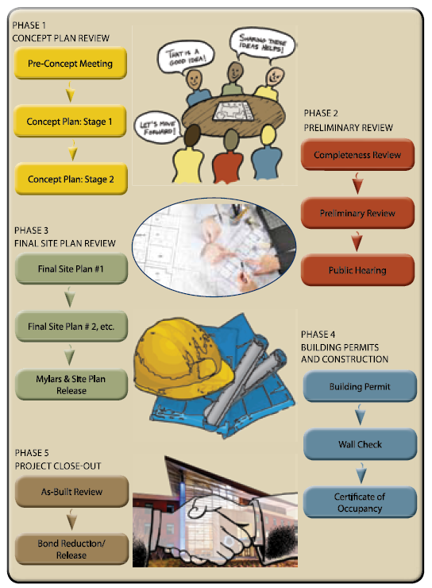
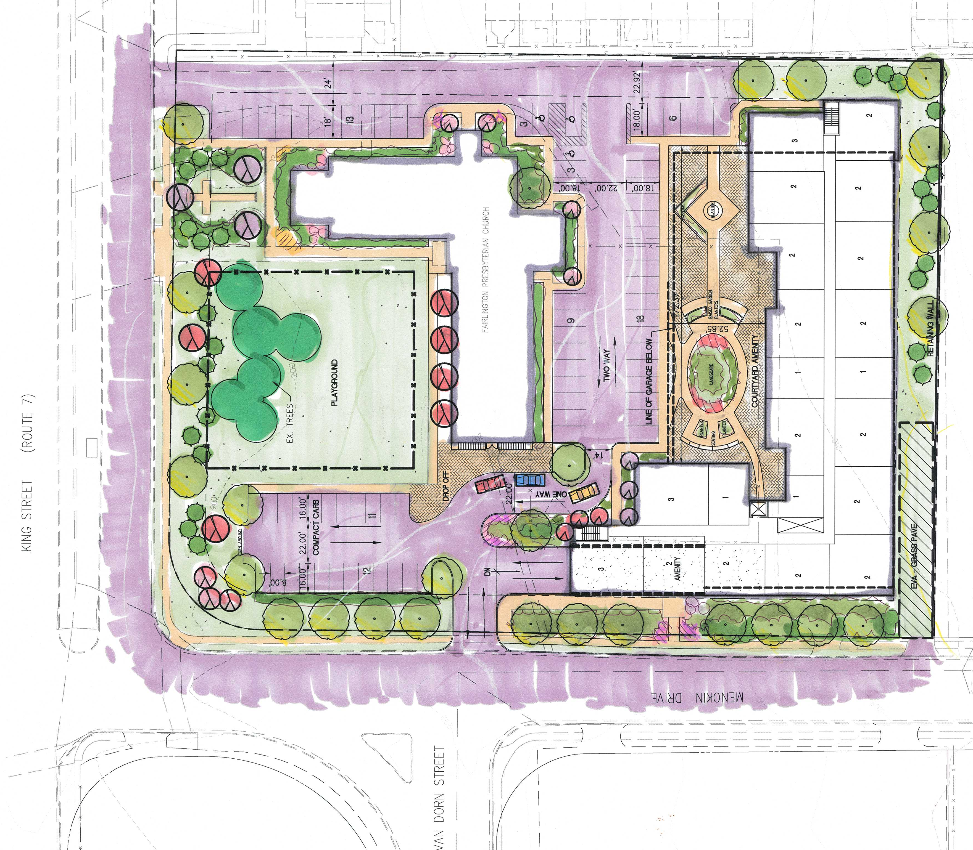
Ongoing Communication
WHDC remains committed to working in partnership with the Church and the surrounding community in order to create and execute an agreeable plan. There will be a continuation of the Design Working Group to facilitate the partnership with the Fairlington Presbyterian Church and shared communication approach. Further, Wesley Housing is committed to working with the neighboring community to ensure a smooth design and communication process. Community meetings and an online interactive communication tool will be used to ensure appropriate and sufficient forums for feedback to be provided and questions answered.

